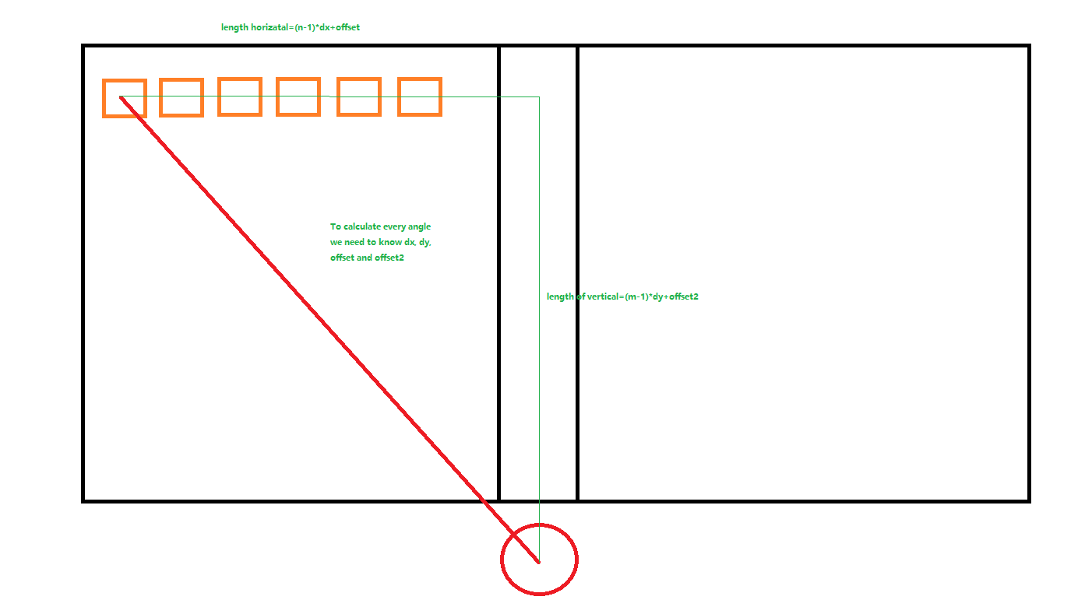

Assumption:

n=5, lx=10, ly=10, dx=1.

Code:

lx=10;

ly=10;

angle=zeros(5);

for i=1:5

x=(lx-(i-1));

y=ly;

angle(i)=atan(y/x);

disp(rad2deg(angle(i)));

end

Robot joint test:

45

48.0128

51.3402

55.0080

59.0362

